**DEPT. OF ELECTRICAL & ELECTRONICS ENGINEERING SRM INSTITUTE OF SCIENCE AND TECHNOLOGY, Kattankulathur – 603203.**

|  |
| --- |
| Title of Experiment : **12. Study of modulation and demodulation techniques.** |
| Name of the candidate : Debarghya Barik    Register Number : RA2011026010022    Date of Experiment : 12.01.2021 |

|  |  |  |  |
| --- | --- | --- | --- |
| Sl.  No. | Marks Split up | Maximum marks  (50) | Marks obtained |
| 1 | Pre Lab questions | 5 |  |
| 2 | Preparation of observation | 15 |  |
| 3 | Execution of experiment | 15 |  |
| 4 | Calculation / Evaluation of Result | 10 |  |
| 5 | Post Lab questions | 5 |  |
| **Total** |  | **50** |  |

**Staff Signature PRE-LAB QUESTIONS**

1. **What is meant by modulation and demodulation in communication?**

**Ans: Modulation** is the process of influencing data information on the carrier signal before transmitting it over long distances.

**Demodulation** is defined as extracting the original information-carrying signal from a modulated carrier wave. A demodulator is an electronic circuit that is mainly used to recover the information content from the modulated carrier wave.

1. **What is modulation and demodulation?**

**Ans:** To involve data information or speech information, another wave has to be imposed known as input signal above the carrier wave. This process of imposing an input signal on a carrier wave is known as **modulation.**

**Demodulation** is the recovery of original information at the distant end (Receiver’s end) from the carrier signal after it travelled.

1. **What is modulation and what is the purpose of it?**

**Ans: Modulation** is the process of changing the parameters of the carrier signal, in accordance with the instantaneous values of the modulating signal.

**Need for Modulation:**

The baseband signals are incompatible for direct transmission. For such a signal, to travel longer distances, its strength has to be increased by modulating with a high frequency carrier wave, which doesn’t affect the parameters of the modulating signal

1. **Compare AM and FM**

**Ans:**  The main difference between both modulations is that in frequency modulation, the frequency of the carrier wave is modified as per the transmit data, while in [amplitude modulation](https://byjus.com/jee/amplitude-modulation/), the carrier wave is modified according to the data.

1. **What is the difference between a modem and router?**

**Ans: Modem -** The name modem is a shorthand expression derived from the technical processes that the device performs, i.e. **modulation**and **demodulation**.

**Router -** Routers are computer networking devices that serve two primary functions:

**[1]** create and maintain a local area network, and

**[2]** manage the data entering and leaving the network and the data moving inside of it.

**Experiment No. 12 Study of modulation and demodulation techniques.**

**Date : 12.01.2021**

**Aim**: To study the different modulation and demodulation techniques

**Theory:**

**Modulation and demodulation**

Communication is the basic attraction of mankind as it gives the knowledge of what is going on around us. In our daily life, we communicate with many people and use the entertainment media like television, radio, internet and newspaper to get ourselves involved. These entertainment media act as a source of communication**.** [**Electronic communication**](http://www.edgefx.in/latest-zigbee-communication-based-projects-for-patients-monitoring/) comprises TV, radio, internet, etc. When we want to transmit a signal from one location to another, we have to strengthen the signal. After undergoing strengthening process the signal travels to a long distance. This is called as modulation, and this article gives an overview of the modulation and [types of modulation techniques.](http://www.elprocus.com/different-types-of-modulation-techniques-in-communication-systems/)

Communication is nothing but, the process of exchanging (two way communications) or passing (one way communication) information from one person to another. The basic electronic communication system consists of these components: transmitter, receiver and communication channel.

**Types of Modulation**

Communication is the basic attraction of mankind as it gives the knowledge of what is going on around us. In our daily life, we communicate with many people and use the entertainment media like television, radio, internet and newspaper to get ourselves involved. These entertainment media act as a source of communication. Electronic communication comprises TV, radio, internet, etc. When we want to transmit a signal from one location to another, we have to strengthen the signal. After undergoing strengthening process the signal travels to a long distance. This is called as modulation, and this article gives an overview of the modulation and types of modulation techniques.

Communication is nothing but, the process of exchanging (two way communications) or passing (one way communication) information from one person to another. The basic electronic communication system consists of these components: transmitter, receiver and communication channel.

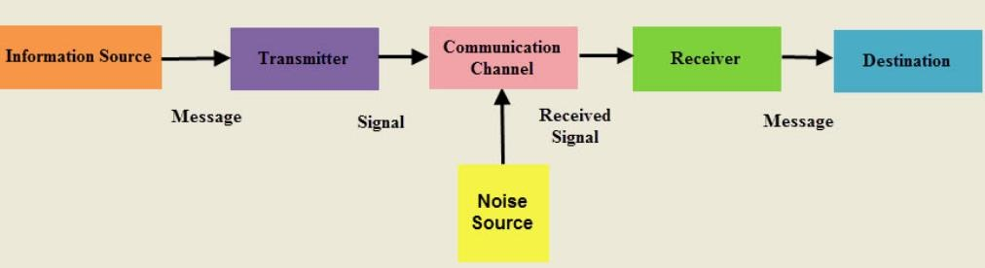

# Figure 1. Communication System

A transmitter is a group of electronic circuits designed to convert the information into a signal for transmission over a given communication medium.

A receiver is a group of electronic circuits designed to convert the signal back to the original information.

The communication channel is the medium which is designed to transmit the electronic signal from one place to another.

Modulation is a way of sending signals of low frequency over long distances without a huge loss of energy by the use of another wave of very high frequency called a carrier wave.

Modulation is nothing but, a carrier signal that varies in accordance with the message signal. Modulation technique is used to change the signal characteristics. Basically, the modulation is of following two types:

* Analog Modulation
* Digital Modulation

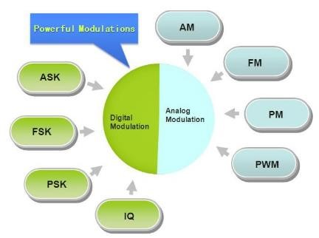

# Figure 1. Types of Modulation

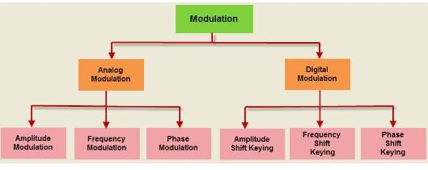

# Figure 2. Modulation Techniques

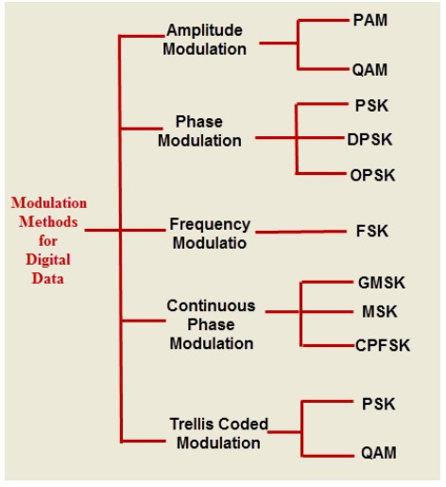

# Figure 3. Types of Digital Modulation Techniques

High frequency signals are more directional and because high frequency waves have a small wavelength there is less diffraction. Also smaller aerials are needed because the size of the aerial has to be of the same sort of size as the wavelength of the signal to be transmitted.

Therefore a sound with a frequency of 256 Hz (middle C) received by a microphone, converted to an electrical signal and then transmitted would have a wavelength of 300000000/256 = 1 170 000 m, over 1000 km!

However a wave of frequency 100 MHz has a wavelength of only 3 m.

We can compare amplitude modulation with a long tube of soft clay on a conveyor belt. The clay moves between the hands of two people, one at each end of the belt.

Modulation – the person at one end moulds the clay by pressing on it as it moves between their hands. By squeezing and relaxing they make a tube of clay with a changing diameter.

At the other end of the belt there is a person with their eyes shut and their hands on either side of the clay at the other end. As the clay moves past their hands are forced in and out by the changing diameter of the clay cylinder. This is called detection

In reality we start with a carrier wave of very high frequency and add to it the audio signal (of relatively low frequency). This addition of the audio signal is called modulation. This can be done either by changing the amplitude of the carrier wave (amplitude modulation) or by changing its frequency (frequency modulation).

The audio signal is produced (Figure 1) and converted to an electrical signal by the



Figure 1

microphone.

The high frequency carrier wave (with a frequency of say 100 MHz) (Figure 2) is



Figure 2

produced by the transmitter.

These two signals are added together (modulation) (Figure 3).



Figure 3

The modulated signal is transmitted (Figure 4).



Figure 4

The modulated signal is received by the aerial.

A diode is used to separate the high frequency carrier wave from the low frequency audio signal (demodulation) by removing half the signal. This leaves the outline of the audio signal (Figure 5).



Figure 5

This signal is now amplified and fed to a loudspeaker.

The receiver is tuned to the carrier wave frequency. The following two diagrams (Figures 6 and 7) show two carrier waves of different frequency both modulated by the same frequency audio signal.

Figures 6 and 7



**Result: The characteristics of the wave and modulation and demodulation techniques are studied.**

**POST-LAB QUESTIONS**

1. **What are the different types of modulation?**

**Ans: There are three types of modulation, namely:**

* **Frequency Modulation** - The amplitude of the carrier signal is changed in proportion to the message signal while the phase and frequency are kept constant.
* **Amplitude Modulation** - The phase of the carrier signal is altered according to the low frequency of the message signal is called phase modulation.
* **Phase Modulation** - The frequency of the carrier signal is altered in proportion to the message signal while the phase and amplitude are kept constant is called [frequency modulation](https://byjus.com/jee/frequency-modulation/).

1. **Which type of modulation is used in television?**

**Ans:** During the **tv** transmission, Frequency **modulation** (FM) is used for audio transmission and amplitude **modulation** (AM) is used for picture transmission.

All analog **television** systems use **vestigial sideband modulation**, a **form** of **amplitude modulation** in which one sideband is partially removed. This reduces the bandwidth of the transmitted signal, enabling narrower channels to be **used**.

1. **What is PPM modulation?**

**Ans: Pulse-position modulation** (**PPM**) is a form of signal **modulation** in which M message bits are encoded by transmitting a single pulse in one of possible required time shifts. This is repeated every T seconds, such that the transmitted bit rate is. bits per second.

1. **What is PWM modulation?**

**Ans: Pulse width modulation** (**PWM**) is a **modulation** technique that generates variable-width pulses to represent the amplitude of an analog input signal.

1. **What are NTSC and PAL?**

**Ans: NTSC** and **PAL** are **Television Standards**

**NTSC (National Television Standards Committee)**

The majority of 60Hz based countries use a technique known as NTSC originally developed in the United States. NTSC works perfectly in a video or closed-circuit environment but can exhibit problems of varying colour when used in a broadcast environment.

**PAL (Phase Alternate Lines)**

A modified version of NTSC soon appeared which differed mainly in that the sub-carrier phase was reversed on each second line, this is known as PAL, standing for Phase Alternate Lines. PAL has been adopted by a few 60Hz countries, most notably Brazil.

---------------------------------------------------------------------------------------------------------------------